

**School of Computing Science and Engineering**

**Lab exercise - 2**

|  |  |  |  |  |  |
| --- | --- | --- | --- | --- | --- |
| **Code/Course** | **:** | **CSE3020 – Data Visualization** | **Date** | **:** | **17/02/2021** |
|  |  |  |  |  |  |
| **Lab Experiment** |  | **Constructing the various visual analytics charts using Lattice Plots in R.** | **Slot** | **:** | **L13+14** |

**Pre-requisite:** We will assume you are moderately familiar with basic concepts in R, including variables and functions, and with RStudio, the integrated development environment for programming in R.

**Practical Exercise: Lattice Plots in R**

**Construct the following charts using “ggplot2” wherever applicable for the given data set hsb2.csv**

**https://www.openintro.org/data/index.php?data=hsb2**

The data file called ***hsb2*,**high school and beyond. This data file contains 200 observations from a sample of high school students with demographic information about the students, such as their gender (**female**), socio-economic status (**ses**) and ethnic background (**race**). It also contains a number of scores on standardized tests, including tests of reading (**read**), writing (**write**), mathematics (**math**) and social studies (**socst**).

Core lattice plots

1. Univariate Plots

One of the great strengths of R is the graphics capabilities. Not only is it very easy to generate great looking graphs, but it is very simply to extend the standard graphics abilities to include conditional graphics. These are very useful both when exploring data and when doing statistical analysis. For each type of graph we will start out looking at the basic graph and then show how to modify the code to produce a conditional graph. In all the conditional plots we will be using the factor variable **ses.f**. For more information on factor variables and how to generate them please refer to the *factor variable learning module.*  Also, you will need to load the package "lattice" before you start.  You can download "lattice" from the CRAN website from within R by clicking on "Packages" and then "Install package(s) from CRAN".    
  
**The first type of graph is a histogram plot.**

**hsb2 <- read.table('http://www.ats.ucla.edu/stat/r/modules/hsb2.csv', header=T, sep=",")**

**attach(hsb2)**

**library(lattice)**

**#defining ses.f to be a factor variable**

**hsb2$ses.f = factor(hsb2$ses, labels=c("low", "middle", "high"))**

**#histograms**

**histogram(~write, hsb2)**

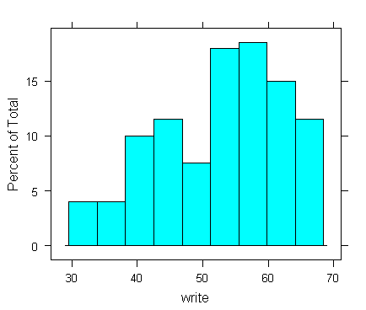

**#conditional plot**

**histogram(~write | ses.f, hsb2)**

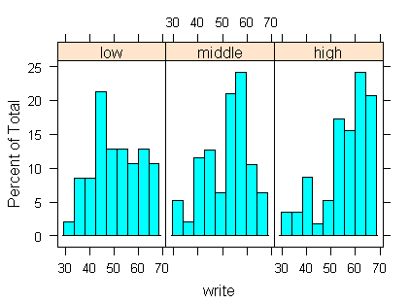

Density plots

**densityplot(~socst, hsb2)**

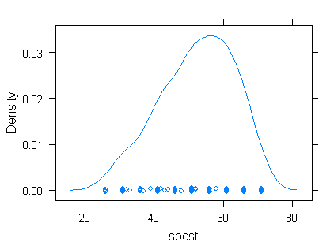

**#conditional plot**

**densityplot(~socst | ses.f, hsb2)**

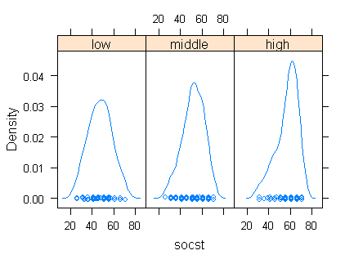

Quantile-quantile plots

**qqmath(~write, hsb2)**

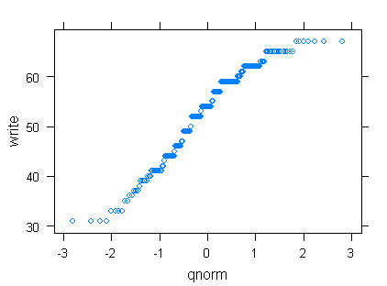

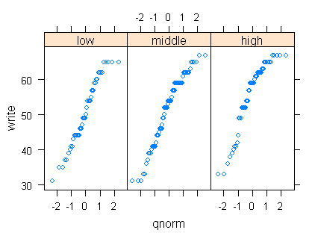

Box and whiskers plots

**bwplot(~math, hsb2)**

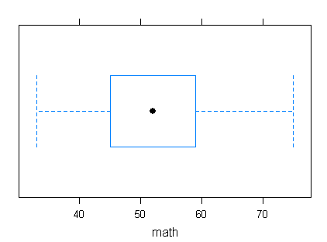

**#conditional plot**

**bwplot(ses.f~math, hsb2)**

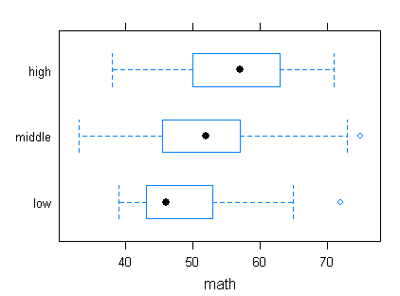

2. Multivariate Plots

Scatter plots

**xyplot(write~math, hsb2)**

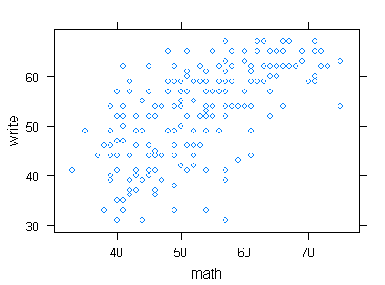

**#conditional plot**

**xyplot(write~math | ses.f, hsb2)**

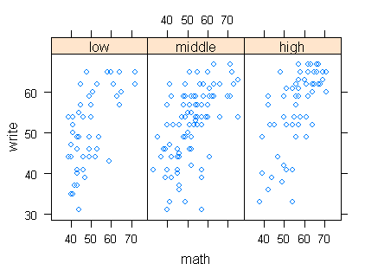

Scatter plot matrices

**subset <- hsb2[ , 8:12]**

**splom(~subset[ , 1:4])**

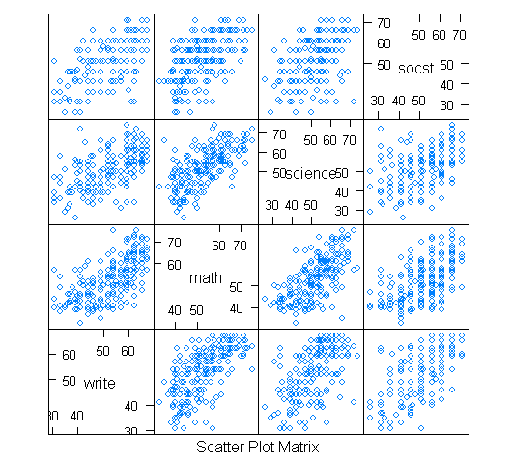

**#conditional plot**

**splom(~subset[, 1:3] | subset[, 5])**

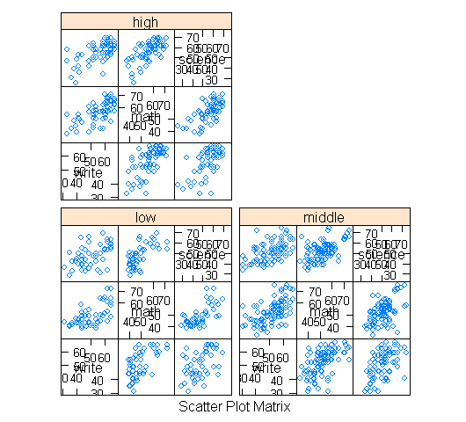

3. Examples of Plots Used in Statistical Analysis

In regression analysis it can be very helpful to use diagnostic plots to assess the fit of the model. In R there are a number of built in plots that can be accessed with minimal effort or code.

**reg <- lm(write~math+socst+ses.f, hsb2)**

**par(mfrow=c(3,2))**

**plot(reg, which=1:2)**

**plot(reg, which=3:4)**

**plot(reg, which=5:6)**

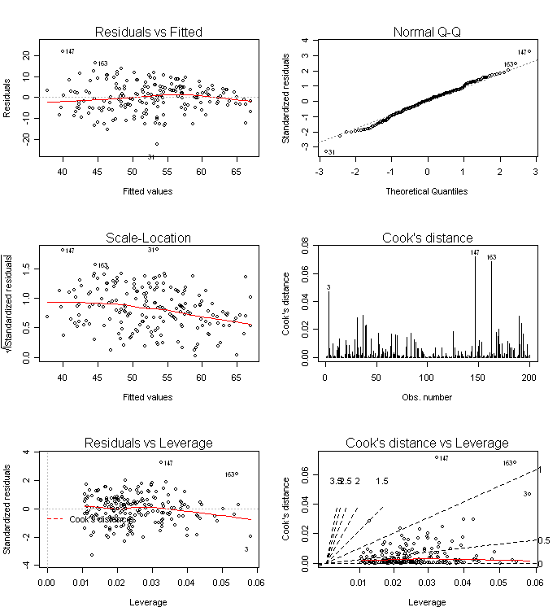

**detach(hsb2)**